TASK 04
#include <iostream>
using namespace std;

#define capacity 100

class MinHeap {
public:
int heap[capacity];
int size;

MinHeap() : size(0) {}

int parent(int i) {return (i - 1)/2;}
int leftChild(int i) {return 2*i + 1;}
int rightChild(int i) {return 2*i + 2;}

void minHeapify(int i) {
int smallest = i;
int left = leftChild(i);
int right = rightChild(i);

if (left < size && heap[left] < heap[smallest]) {
smallest = left;
}
if (right < size && heap[right] < heap[smallest]) {
smallest = right;
}

if (smallest != i) {
swap(heap[i], heap[smallest]);
minHeapify(smallest);
}
}

void insert(int value) {
if (size == capacity) {
cout << "Heap is full!!" << endl;
return;
}

cout << "Inserting value: " << value << endl;

heap[size] = value;
size++;

int i = size - 1;
while (i != 0 && heap[parent(i)] > heap[i]) {
swap(heap[i], heap[parent(i)]);
i = parent(i);
}
printHeap();
}

void removeMin() {
if (size <= 0) {
cout << "Heap is empty!!" << endl;
return;
}
if (size == 1) {
size--;
return;
}
heap[0] = heap[size - 1];
size--;

minHeapify(0);
}

void printHeap() {
cout << "Heap elements: ";
for (int i = 0; i < size; i++) {
cout << heap[i] << " ";
}
cout << endl;
}

};

int main() {
MinHeap minHeap;

minHeap.insert(8);
minHeap.insert(12);
minHeap.insert(4);
minHeap.insert(9);
minHeap.insert(1);
minHeap.insert(6);

return 0;
}

PART 1
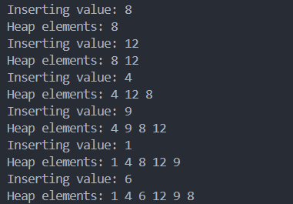
PART 2
int main() {
MinHeap minHeap;

minHeap.insert(7);
minHeap.insert(3);
minHeap.insert(10);
minHeap.insert(2);

return 0;
}

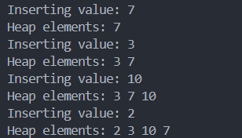

PART 3
int main() {
MinHeap minHeap;

minHeap.insert(2);
minHeap.insert(4);
minHeap.insert(5);
minHeap.insert(10);
minHeap.insert(8);
minHeap.insert(6);
minHeap.insert(9);

minHeap.removeMin();
minHeap.printHeap();

return 0;
}

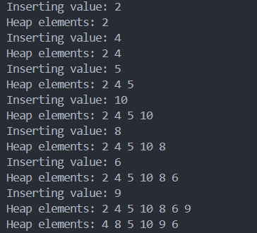

TASK 03
1)
#include <iostream>
using namespace std;

#define capacity 100

class MaxHeap {
public:
int heap[capacity];
int size;

MaxHeap() : size(0) {}

int parent(int i) {return (i - 1)/2;}
int leftChild(int i) {return 2*i + 1;}
int rightChild(int i) {return 2*i + 2;}

void maxHeapify(int i) {
int largest = i;
int left = leftChild(i);
int right = rightChild(i);

if (left < size && heap[left] > heap[largest]) {
largest = left;
}
if (right < size && heap[right] > heap[largest]) {
largest = right;
}

if (largest != i) {
swap(heap[i], heap[largest]);
maxHeapify(largest);
}
}

void insert(int value) {
if (size == capacity) {
cout << "Heap is full!!" << endl;
return;
}

cout << "Inserting value: " << value << endl;

heap[size] = value;
size++;

int i = size - 1;
while (i != 0 && heap[parent(i)] < heap[i]) {
swap(heap[i], heap[parent(i)]);
i = parent(i);
}
printHeap();
}

void removeMax() {
if (size <= 0) {
cout << "Heap is empty!!" << endl;
return;
}
if (size == 1) {
size--;
return;
}
heap[0] = heap[size - 1];
size--;

maxHeapify(0);
}

void deleteVal(int val) {
int i;
for (i = 0; i < size; i++) {
if (val == heap[i])
break;
}

if (i == size) {
cout << "Value not found in heap!" << endl;
return;
}

heap[i] = heap[size - 1];
size--;
maxHeapify(i);
}

void printHeap() {
cout << "Heap elements: ";
for (int i = 0; i < size; i++) {
cout << heap[i] << " ";
}
cout << endl;
}

};

int main() {

MaxHeap maxheap;
maxheap.insert(25);
maxheap.insert(30);
maxheap.insert(35);
maxheap.insert(11);
maxheap.insert(15);
maxheap.insert(19);
maxheap.insert(18);
maxheap.insert(55);
maxheap.insert(78);
maxheap.insert(36);

maxheap.deleteVal(55);
maxheap.printHeap();

return 0;
}

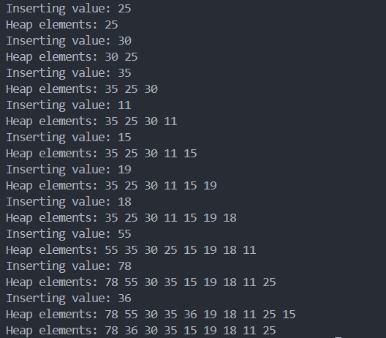

2)
#include <iostream>
using namespace std;

#define capacity 100

class MinHeap {
public:
int heap[capacity];
int size;

MinHeap() : size(0) {}

int parent(int i) {return (i - 1)/2;}
int leftChild(int i) {return 2*i + 1;}
int rightChild(int i) {return 2*i + 2;}

void minHeapify(int i) {
int smallest = i;
int left = leftChild(i);
int right = rightChild(i);

if (left < size && heap[left] < heap[smallest]) {
smallest = left;
}
if (right < size && heap[right] < heap[smallest]) {
smallest = right;
}

if (smallest != i) {
swap(heap[i], heap[smallest]);
minHeapify(smallest);
}
}

void insert(int value) {
if (size == capacity) {
cout << "Heap is full!!" << endl;
return;
}

cout << "Inserting value: " << value << endl;

heap[size] = value;
size++;

int i = size - 1;
while (i != 0 && heap[parent(i)] > heap[i]) {
swap(heap[i], heap[parent(i)]);
i = parent(i);
}
printHeap();
}

void deleteVal(int val) {
int i;
for (i = 0; i < size; i++) {
if (val == heap[i])
break;
}

if (i == size) {
cout << "Value not found in heap!" << endl;
return;
}

heap[i] = heap[size - 1];
size--;
minHeapify(i);
}

void removeMin() {
if (size <= 0) {
cout << "Heap is empty!!" << endl;
return;
}
if (size == 1) {
size--;
return;
}
heap[0] = heap[size - 1];
size--;

minHeapify(0);
}

void printHeap() {
cout << "Heap elements: ";
for (int i = 0; i < size; i++) {
cout << heap[i] << " ";
}
cout << endl;
}

};

int main() {
MinHeap minheap;
minheap.insert(25);
minheap.insert(30);
minheap.insert(35);
minheap.insert(11);
minheap.insert(15);
minheap.insert(19);
minheap.insert(18);
minheap.insert(55);
minheap.insert(78);
minheap.insert(36);

minheap.deleteVal(18);
minheap.printHeap();

return 0;
}

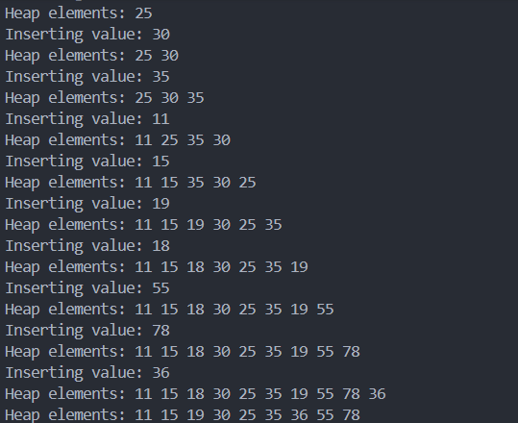

TASK 01
#include <iostream>
using namespace std;

#define capacity 100

class MinHeap {
public:
int heap[capacity];
int size;

MinHeap() : size(0) {}

int parent(int i) {return (i - 1)/2;}
int leftChild(int i) {return 2*i + 1;}
int rightChild(int i) {return 2*i + 2;}

void minHeapify(int i) {
int smallest = i;
int left = leftChild(i);
int right = rightChild(i);

if (left < size && heap[left] < heap[smallest]) {
smallest = left;
}
if (right < size && heap[right] < heap[smallest]) {
smallest = right;
}

if (smallest != i) {
swap(heap[i], heap[smallest]);
minHeapify(smallest);
}
}

void insert(int value) {
if (size == capacity) {
cout << "Heap is full!!" << endl;
return;
}

cout << "Inserting value: " << value << endl;

heap[size] = value;
size++;

int i = size - 1;
while (i != 0 && heap[parent(i)] > heap[i]) {
swap(heap[i], heap[parent(i)]);
i = parent(i);
}
printHeap();
}

void removeMin() {
if (size <= 0) {
cout << "Heap is empty!!" << endl;
return;
}
if (size == 1) {
size--;
return;
}
heap[0] = heap[size - 1];
size--;

minHeapify(0);
}

void printHeap() {
cout << "Heap elements: ";
for (int i = 0; i < size; i++) {
cout << heap[i] << " ";
}
cout << endl;
}

};

int main() {
MinHeap minHeap;

minHeap.insert(8);
minHeap.insert(12);
minHeap.insert(4);
minHeap.insert(9);
minHeap.insert(1);

minHeap.printHeap();

minHeap.insert(2);

minHeap.printHeap();

minHeap.insert(2);
minHeap.printHeap();

minHeap.insert(1);
minHeap.insert(5);
minHeap.printHeap();
return 0;
}

